Preparation of Papers for GLOREP Conference(NOVEMBER 2018) (24 points, bold, center)

First Name, Family Name Author*, First Name, Family Name Author(TNR, 11 points, centered, capitalize first letter
*corresponding author
Abstract: (TNR, 10 points, bold, justify) These instructions give you guidelines for preparing papers for GLOREP CONFERENCE, November, 2018. Use this document as a template if you are using Microsoft Word 2007 or later. Otherwise, use this document as an instruction set. Paper titles should be written in uppercase and lowercase letters, not all uppercase. Avoid writing long formulas with subscripts in the title; short formulas that identify the elements are fine (e.g., "Nd–Fe–B"). Full names of authors are preferred in the author field. Put a space between authors’ initials. The abstract must be a concise yet comprehensive reflection of what is in your article, self-contained, without abbreviations, footnotes, or references. Size of abstract should be between 150–250 words, written as one paragraph and mathematical equations or tabular material are not allowed.
Keywords: (TNR, 9 points, bold, justify), enter 4 key words, separated by commas , first is the Topic addressed, as selected from the conference Topics list.

Guidelines For Manuscript Preparation (the title of the chapter is written by capital letters, tnr, 10 points, justify)
For this Conference the files must be sent also in MS Word format to glorep2018@upt.ro and should be formatted for direct printing. Font size of the text of the paper should be 10, TNR, justify. Highlight a section that you want to designate with a certain style, and then select the appropriate name on the style menu. Use this template when preparing the paper. The style will adjust your fonts and line spacing. Do not change the font sizes or line spacing to squeeze more text into a limited number of pages.Use italics for emphasis; do not underline text.
To insert images in Word, position the cursor at the insertion point and either use Insert | Picture | From File or copy the image to the Windows clipboard and then Edit | Paste Special | Picture (with “float over text” unchecked).

Abbreviations and Acronyms
Define abbreviations and acronyms the first time they are used in the text, even after they have already been defined in the abstract. Abbreviations such as “SI”, “ac”, and “dc” do not have to be defined. Abbreviations that incorporate periods should not have spaces: write “C.N.R.S.,” not “C. N. R. S.”

Other Recommendations
Use one space after periods and colons. Hyphenate complex modifiers: “zero-field-cooled magnetization.” Avoid dangling participles, such as, “Using (1), the potential was calculated.” [It is not clear who or what used (1).] Write instead, “The potential was calculated by using (1),” or “Using (1), we calculated the potential.”
Use a zero before decimal points: “0.25,” not “.25.” Use “cm³,” not “cc.” Indicate sample dimensions as “0.1 cm × 0.2 cm,” not “0.1 × 0.2 cm².” The abbreviation for “seconds” is “s,” not “sec.” When expressing a range of values, write “7 to9” or “7-9,” not “7~9.”
If you wish, you may write in the first person singular or plural and use the active voice (“I observed that ...” or “We observed that ...” instead of “It was observed that ...”). Remember to check spelling. If your native language is not English, please get a native English-speaking colleague to carefully proofread your paper.

MATH
If you are using Word, use either the Microsoft Equation Editor or the MathType add-on (http://www.mathtype.com) for equations in your paper (Insert | Object | Create New | Microsoft Equation orMathType Equation). “Float over text” “not” should be selected.

Equations
Number of equations consecutively with equation numbers in parentheses flush with the right margin, as in (1). First use the equation editor to create the equation. Then select the “Equation” markup style. Press the tab key and write the equation number in parentheses. Use parentheses to avoid ambiguities in denominators. Punctuate equations when they are part of a sentence, as in
X = a·b (1)
Be sure that the symbols in your equation have been defined before the equation appears or immediately following. Italicize symbols (T might refer to temperature, but T is the unit tesla). Refer to “(1),” not “Eq. (1)” or “equation (1),” except at the beginning of a sentence: “Equation (1) is ...”

Units
Use SI (MKS). If you must use mixed units, clearly state the units for each quantity in an equation.
Guidelines for Graphics Preparation and Submission
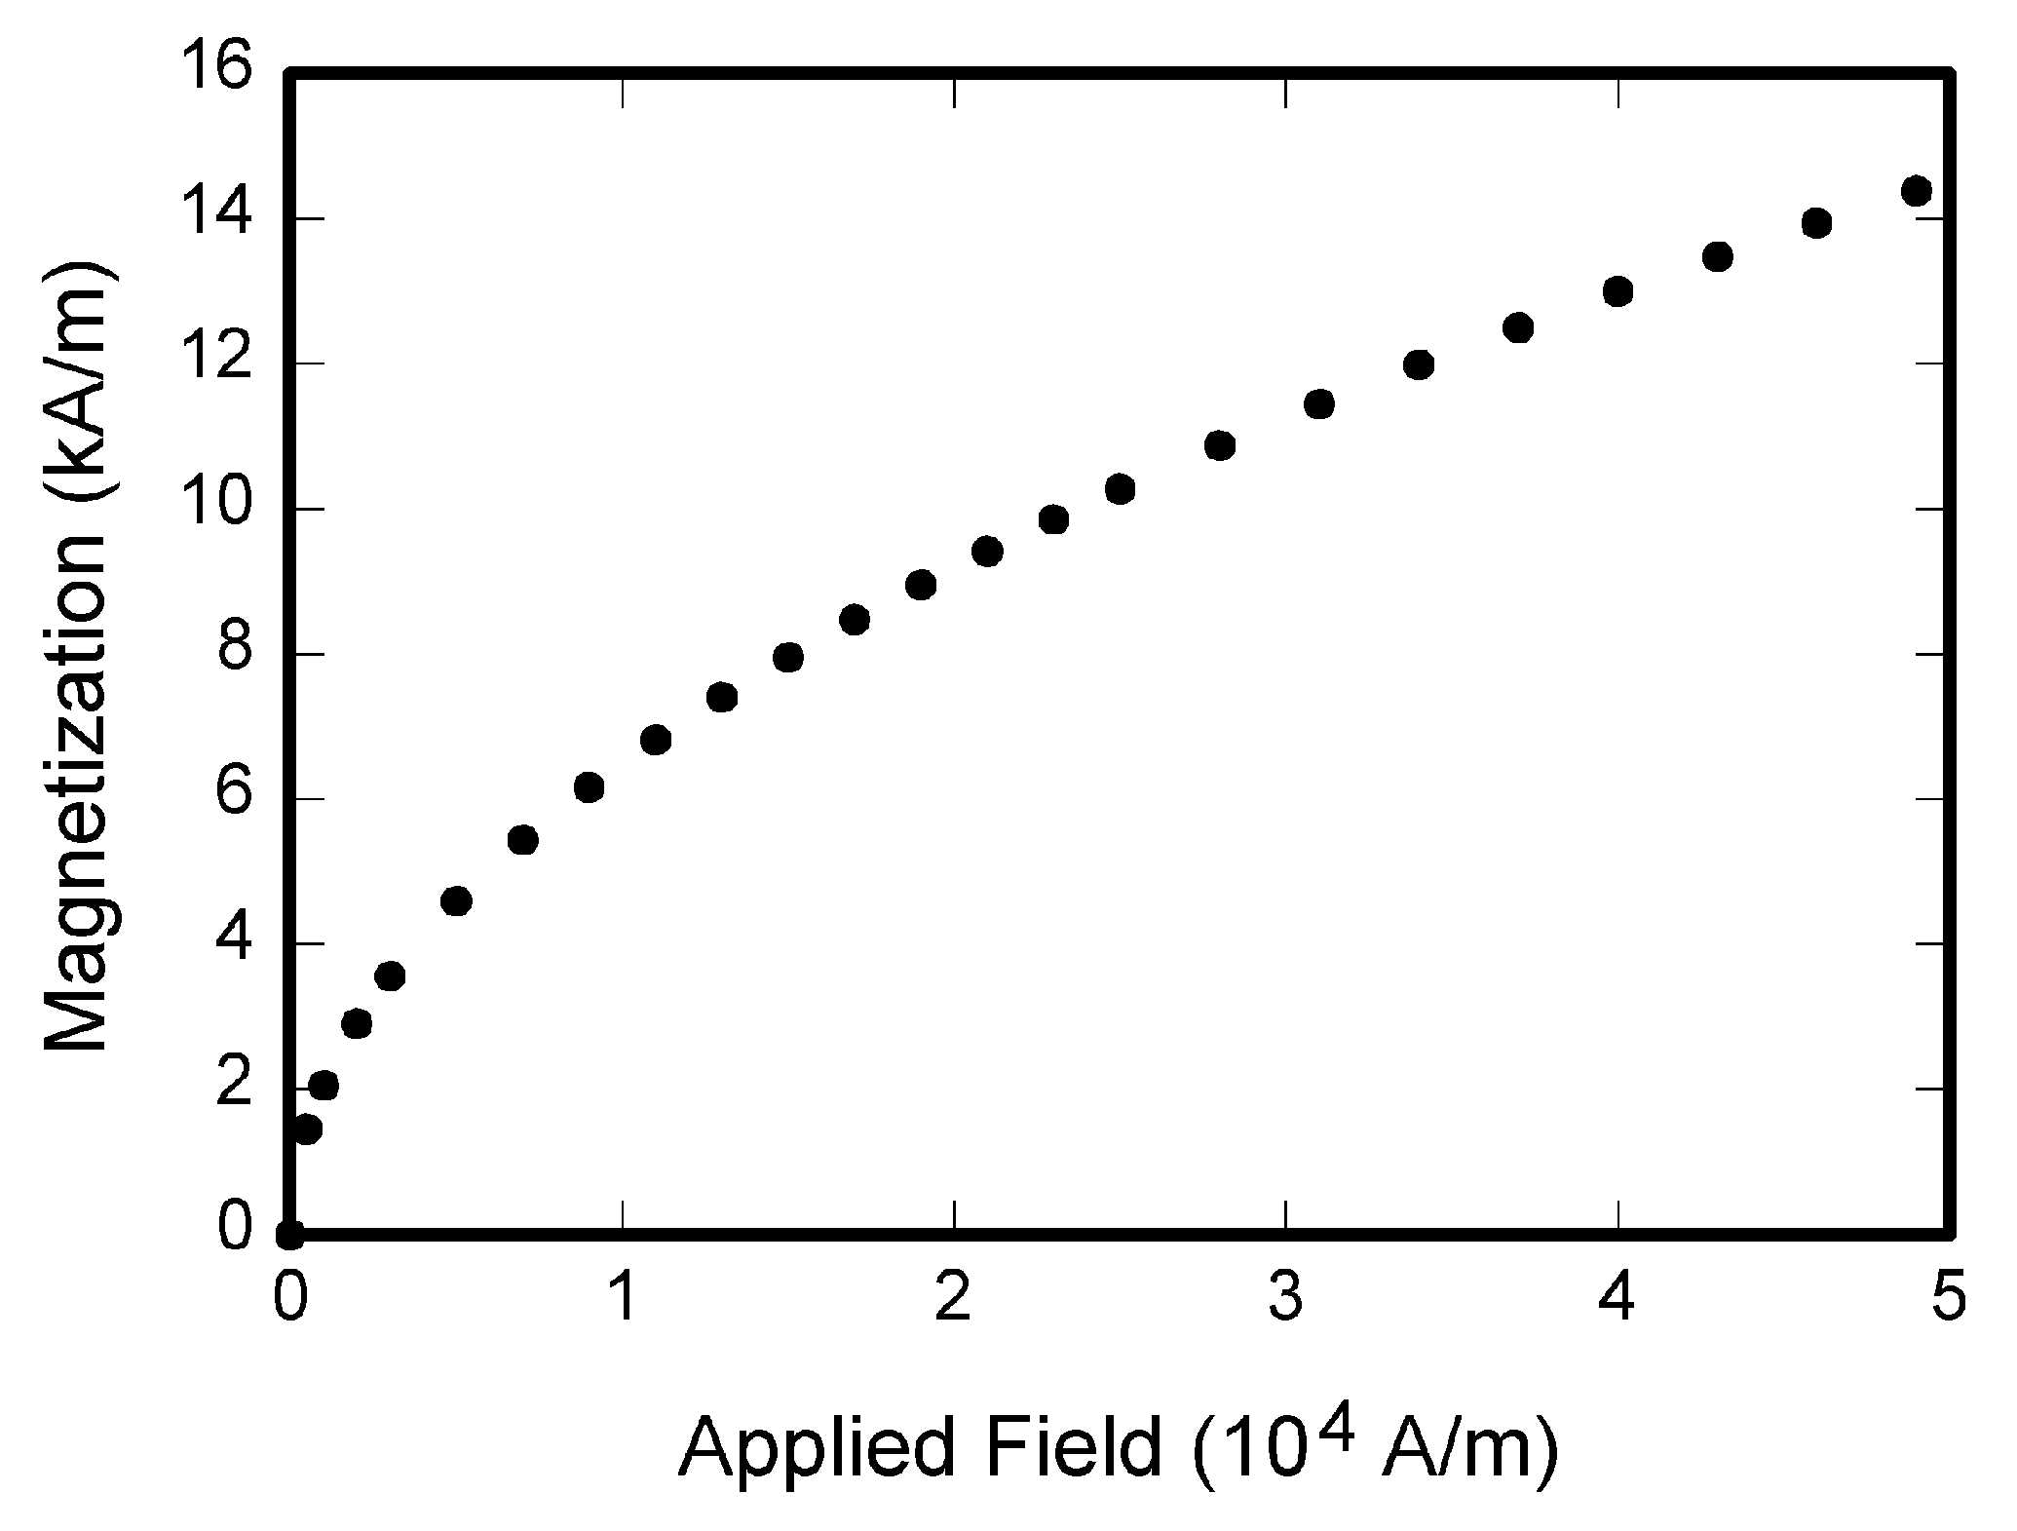
Fig. 1. Magnetization as a function of applied field. Note that “Fig.” is abbreviated. There is a period after the figure number, followed by two spaces. It is good practice to explain the significance of the figure in the caption.

Types of Graphics

Color/Grayscale figures

Figures that are meant to appear in black/gray. Such figures may include photographs, illustrations, and flowcharts.

Line Art figures

Figures that are composed of only black lines and shapes. These figures should have no shades or half-tones of gray, only black and white.

Tables
Data charts which are typically black and white. Headings should be placed above tables, centered. Tables must be embedded into the text and not supplied separately. Tables should be numbered with Roman Numerals. Do not abbreviate “Table.” Below is an example which authors may find useful.
Table I. An example of a table
An example of a column heading | Column A (t) | Column B (T)

File Formats for Graphics
Format and save your graphics using a Tagged Image File Format (.TIFF), Portable Document Format (.PDF), or sizes them, and adjusts the resolution settings. It is strongly recommended that these files be saved in PDF format rather than DOC, XLS, or PPT.

Sizing of Graphics
Most charts, graphs, and tables are one column wide (3.5 inches / 88 millimeters / 21 picas) or page wide (7.16 inches / 181 millimeters / 43 picas). The maximum depth a graphic can be is 8.5 inches (216 millimeters / 54 picas). When choosing the depth of a graphic, please allow space for a caption.

Accepted Fonts Within Figures
When preparing your graphics conference suggests that you use of one of the following Open Type fonts: Times New Roman and Symbol.

Using Labels Within Figures

Figure Axis labels
Figure axis labels are often a source of confusion. Use words rather than symbols. As an example, write the quantity “Magnetization,” or “Magnetization M,” not just “M.” Put units in parentheses. Do not label axes only with units. As in Fig. 1, for example, write “Magnetization (A/m)” or “Magnetization (Am⁻¹),” not just “A/m.” Do not label axes with a ratio of quantities and units. For example, write “Temperature (K),” not “Temperature/K.”
Multipliers can be especially confusing. Write “Magnetization (kA/m)” or “Magnetization (10³ A/m).” Do not write “Magnetization (A/m) × 1000”.

Subfigure Labels in Multipart Figures and Tables
Multipart figures should be combined and labeled before final submission. Labels should appear centered below each subfigure in 8 points Times New Roman font in the format of (a) (b) (c).

Referencing a Figure or Table Within Your Paper
When referencing your figures and tables within your paper, use the abbreviation “Fig.” even at the beginning of a sentence.

Conclusion

A conclusion section is not required. Although a conclusion may review the main points of the paper, do not replicate the abstract as the conclusion. A conclusion might elaborate on the importance of the work or suggest applications and extensions.

Acknowledgment
The preferred spelling of the word “acknowledgment” in American English is without an “e” after the “g.” Use the singular heading even if you have many acknowledgments. Avoid expressions such as “One of us (S.B.A.) would like to thank ...” Instead, write “F. A. Author thanks ...” In most cases, sponsor and financial support acknowledgments are placed in the unnumbered footnote on the first page, not here.

References and Footnotes

References
Authors should ensure that every reference in the text appears in the list of references and vice versa. When they are, they appear on the line, in square brackets, inside the punctuation. Multiple references are each numbered with separate brackets. When citing a section in a book, please give the relevant page numbers. In text, refer simply to the reference number. Do not use “Ref.” or “reference” except at the beginning of a sentence: “Reference [3] shows ...”
Reference numbers are set flush left and form a column of their own, hanging out beyond the body of the reference. The reference numbers are on the line, enclosed in square brackets. In all references, the given name of the author or editor is abbreviated to the initial only and preceed the last name. Use them all; use “et al”. only if names are not given. Other than books, capitalize only the first word in a paper title, except for proper nouns and element symbols. In preparing the list of References attention must be drawn to the following points:
a) Names of all authors of cited publications should be given. Use of “et al.” in the list of references is not acceptable;
b) Only the initials of first and middle names should be given.
Example:
[1]. F. K. VOSNIAKOS, K. S. FARMAKIS: Radioactive Releases from Nuclear and Thermoelectric Power Plant Operation and Their Effect to the Environment of Northern Greece. Journal of Environmental Protection and Ecology, 1 (2), 255-259, 2000.
[2]. E. P. PAPANIKOLAU, P. KRITIDIS: Contamination of the Agricultural Land of Greece with Cs-137 and Its Effect on Crops. In: Intern. Conf. on Radioactivity in the Mediterranean Areas, Barcelona, May, 457-466, 1988.
[3]. K. TASCHNER: Environmental Management and Audit Scheme. EEB Industry Hand­book (Eds C. Key, K. Tashner). Brussels, Belgium, 1998.

Submitting Your Paper for Review

Final Stage Using Word 6.0
When you submit your final version, maximum 4 pages, send it in two-column format, including figures and tables. Include full affiliations and e-mail addresses. Use * for the “corresponding author.” This is the author to whom proofs of the paper will be sent. Proofs are sent to the corresponding author only.

Copyright Form
Authors must submit an electronic Copyright Form (eCF) upon submitting their final manuscript files.
VI. PUBLISHING POLICY
The general policy requires that authors should only submit original work that has neither appeared elsewhere for publication, nor is under review for another refereed publication. The submitting author must disclose all prior publication(s) and current submissions when submitting a manuscript. Do not publish “preliminary” data or results. The submitting author is responsible for obtaining agreement of all coauthors and any consent required from employers or sponsors before submitting an article. The Glorep Conference strongly discourages courtesy authorship; it is the obligation of the authors to cite only relevant prior work.

VII. PUBLICATION PRINCIPLES
The one type of contents of that is published is peer-reviewed.
Authors should consider the following points:
1) Technical papers submitted for publication must advance the state of knowledge and must cite relevant prior work.
2) The length of a submitted paper should be commensurate with the importance, or appropriate to the complexity, of the work. For example, an obvious extension of previously published work might not be appropriate for publication or might be adequately treated in just a few pages.
3) Authors must convince both peer reviewers and the editors of the scientific and technical merit of a paper; the standards of proof are higher when extraordinary or unexpected results are reported.
4) Because replication is required for scientific progress, papers submitted for publication must provide sufficient information to allow readers to perform similar experiments or calculations and use the reported results. Although not everything need be disclosed, a paper must contain new, useable, and fully described information. For example, a specimen’s chemical composition need not be reported if the main purpose of a paper is to introduce a new measurement technique. Authors should expect to be challenged by reviewers if the results are not supported by adequate data and critical details.
5) Papers that describe ongoing work or announce the latest technical achievement, which are suitable for presentation at a professional conference, may not be appropriate for publication.
6) The conference GLOREP 2018 is organized with the support of The Publishing House (EdituraPolitehnica Timisoara), which is editing the Conference proceedings, and the Politehnica Foundation.
7) Depending on the authors’ intention, the quality of the papers, and the final decision of the organizing committee, the papers can be published, in an extended form, with another title, and using the specific format, in other journals, such as JEPE (BENA association), Termotehnica, Buletinul AGIR (AGIR meaning the Association of Romanian Engineers), all in English and citing (self citing) the primary paper, included in the Conference proceeding.
8) Sending your proposals presumes that you agree that the organizers use your e-mail and other personal data, for the conference purposes only.

*The first author affiliations, e-mail
The second author affiliations, e-mail

